- Select Event Trace in the Simulation results window
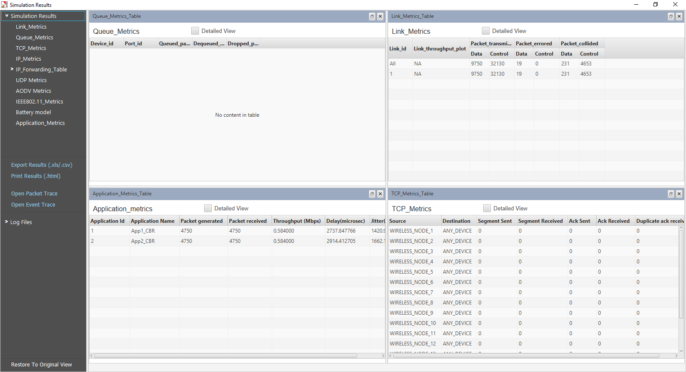
- Click on Pivot Table in INSERT tab

- Then a window named Create Pivot Table pops up which automatically selects the entire table, then click OK button.

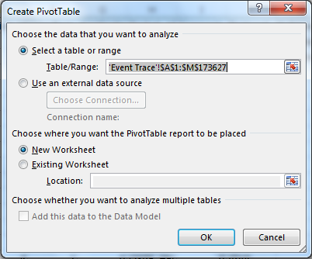

- A blank PivotTable and Field List will appear on a new worksheet.

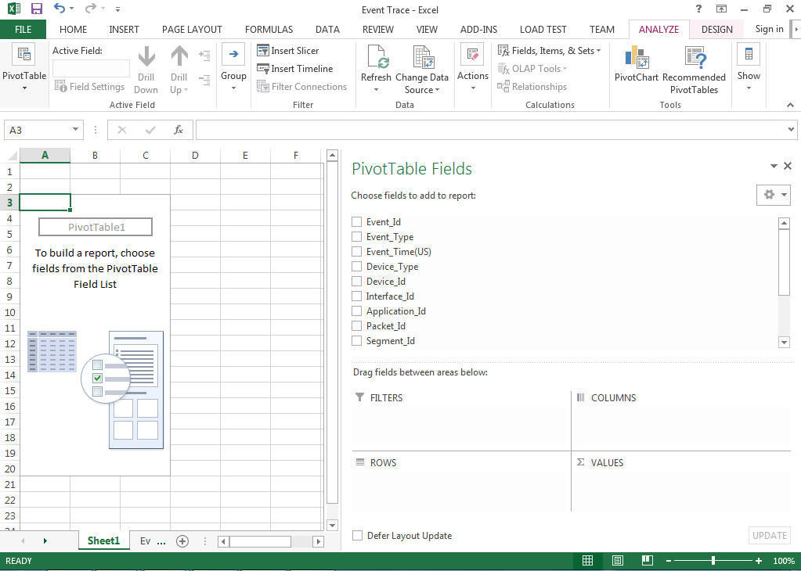

- Once you create a PivotTable, you will need to decide which fields to add. Each field is simply a column header from the source data. In the PivotTable Field List, check the box for each field you want to add.

CASE 1: NO SEGMENTATION
- This case occurs if the application packet size does not get segmented. If there are segments users can see segment 1, segment 2 etc

Without Segmentation:

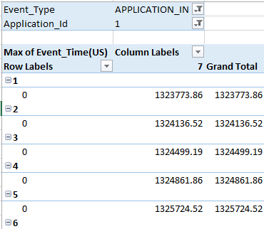

With Segmentation:
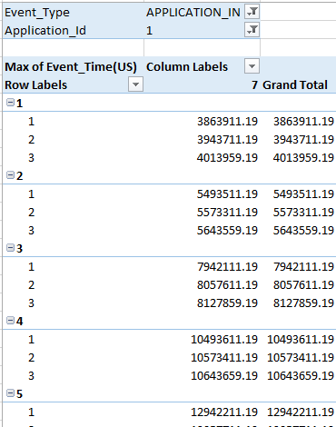

- Drag and drop the Event_Type, Application_Id Fields into FILTERS, Packet_Id into ROWS and Device_Id into COLUMNS.
- Drag and Drop Event_Time Field into VALUES.
- Click on the Event_Time field in the VALUES and select the Value Field Settings.

- A window named Value Field Settings opens then select Max option and click OK button

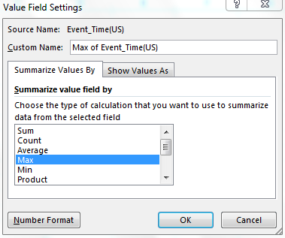

- Then finally the Pivot Table Fields will be as shown below.
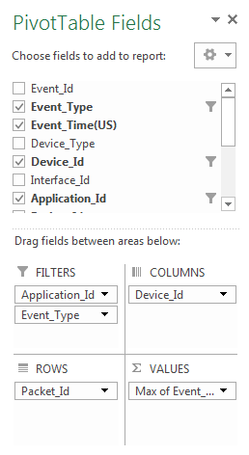
- In the Column Labels Select the Application_Id, in Event_Type select APPLICATION_IN and select Destination_Id.

And the Pivot Table created will be as shown (7(in this case) is the Destination_Id)
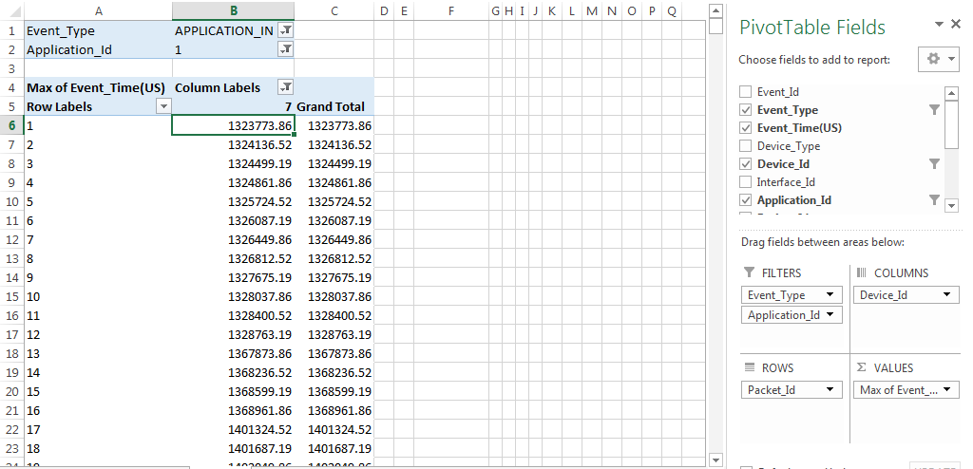

- Selcet one cell in Columns Labels and right click then select Show Values As, then select Difference From,
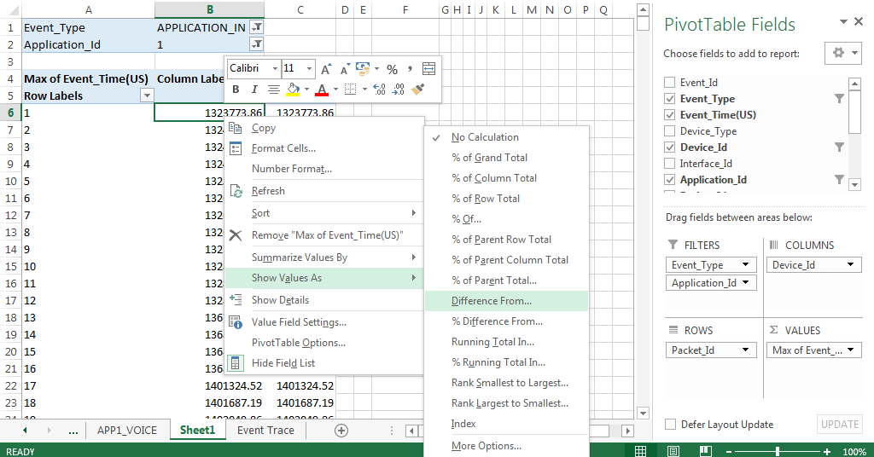
- Then a window named Show Values As open up in that select BaseField as Packet_Id and Base Item as (previous)

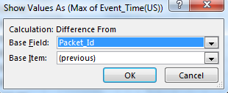
- Place the mouse pointer just below Row Labels then left click, it will automatically selects the entire row of the Row Labels as shown below then in the Name Box name that row (APP_1 in this case)
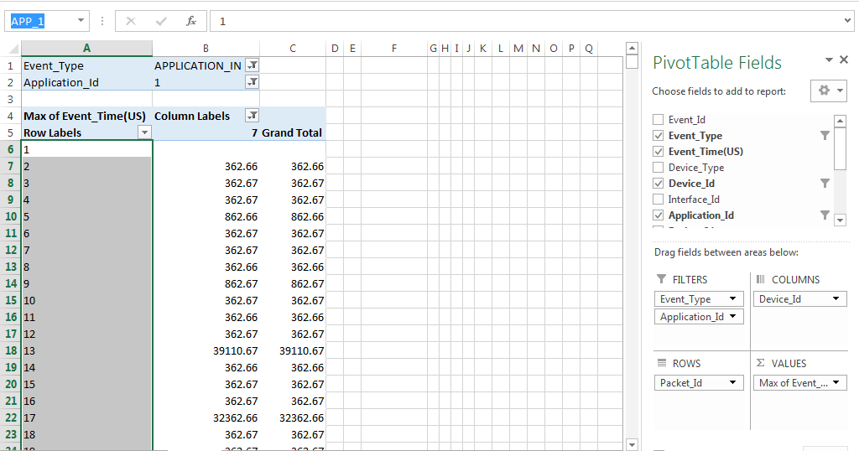
- In an empty cell enter the formula =ADDRESS(ROW(APP_1),COLUMN(D6)) & ":" & ADDRESS(ROW(APP_1)+ROWS(APP_1)-1,COLUMN(D6)), to get the row address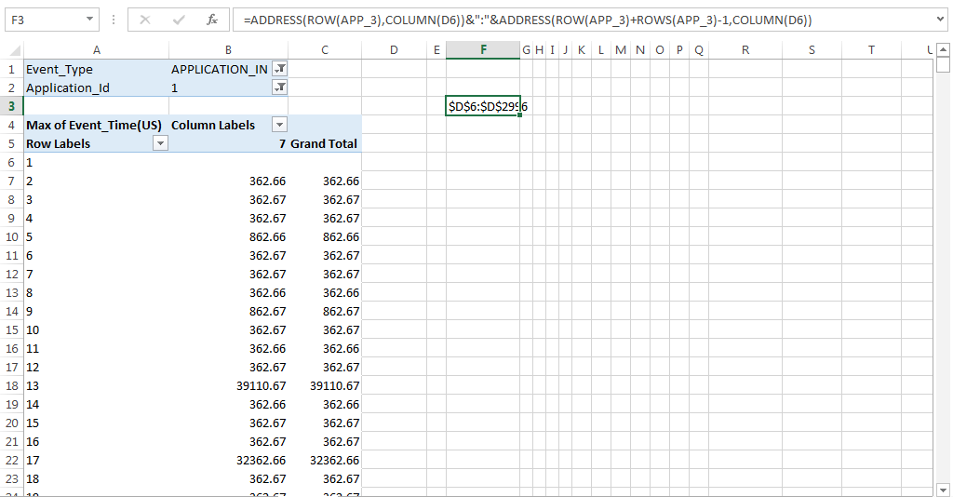

- Then copy the address and paste in the Name Box, and press Enter this selects the rows of Column D. (Name Box is in the left top corner as shown)
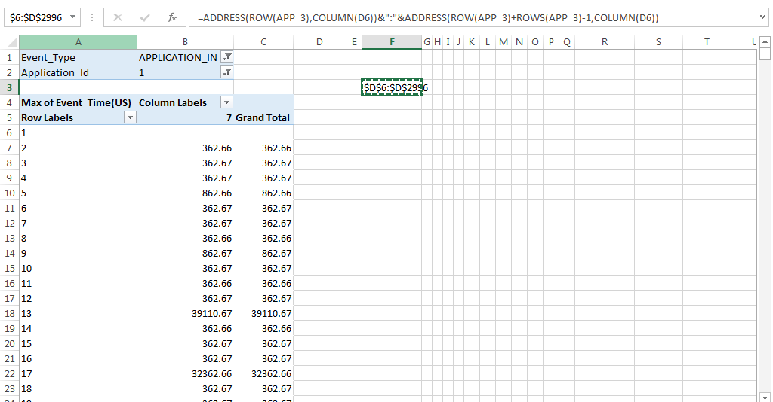

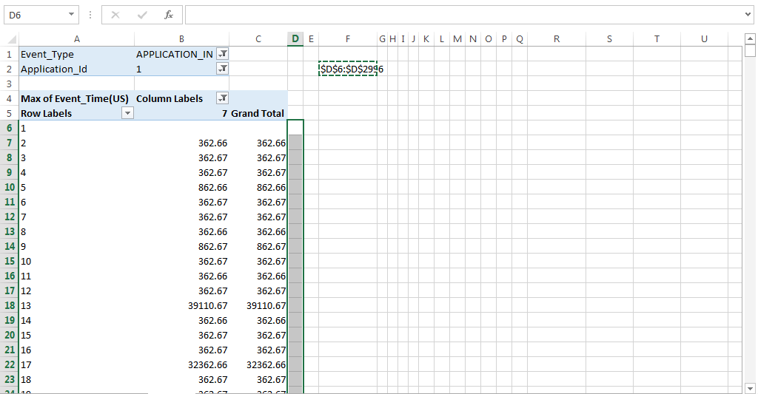

- Now in the Formula box enter the formula =IF(B7<0,1,0) and press CTRL + ENTER
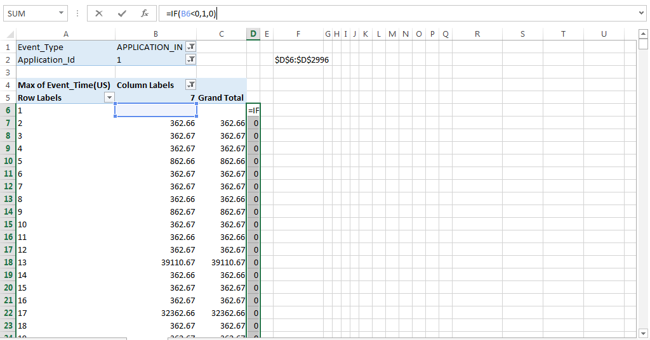

- Then in enter the formula = SUM(D:D) in empty cell which gives the number of out of order packets.
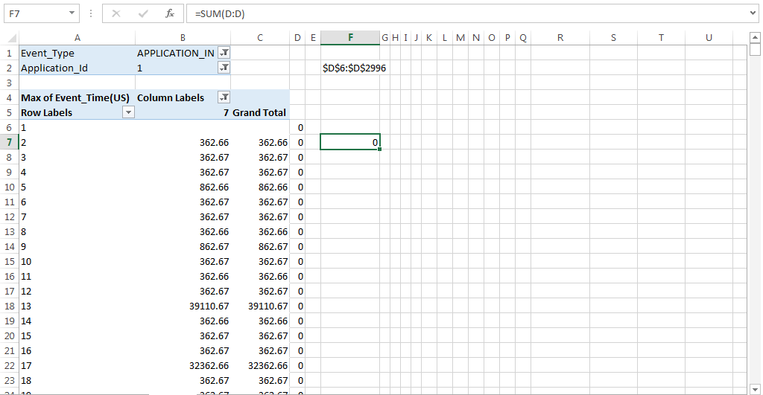

CASE 2: SEGMENTATION
- Drag and drop the Event_Type, Application_Id Fields into FILTERS, Packet_Id and Segment_Id into ROWS and Device_Id into COLUMNS.
- Drag and Drop Event_Time Field into VALUES.
- Click on the Event_Time field in the VALUES and select the Value Field Settings.
- A window named Value Field Settings opens then select Max option and click OK button

- Then finally the Pivot Table Fields will be as shown below.
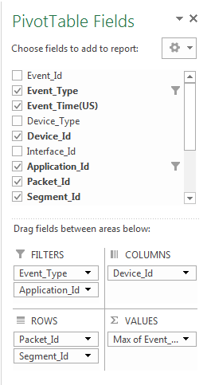
- Select the Application_Id, in Event_Type select APPLICATION_IN and in the Column Labels select Destination_Id.

And the Pivot Table created will be as shown (7(in this case) is the Destination_Id)

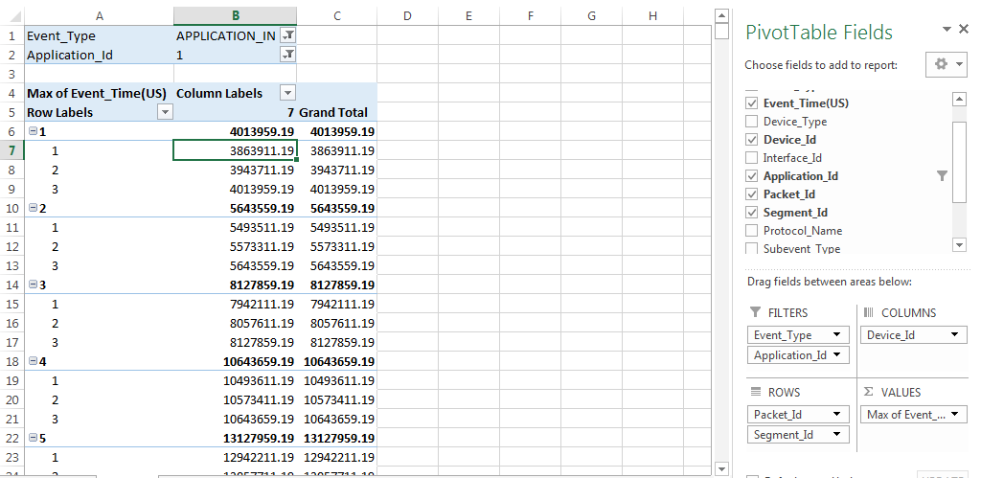

- Select one cell in Row Labels (Packet_Id) and right click and deselect the Subtotal “Packet_Id”
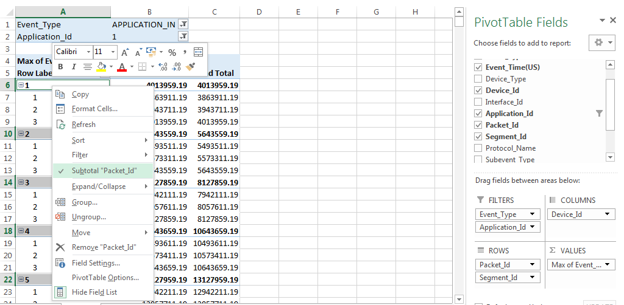
Then it removes the Subtotals as shown below
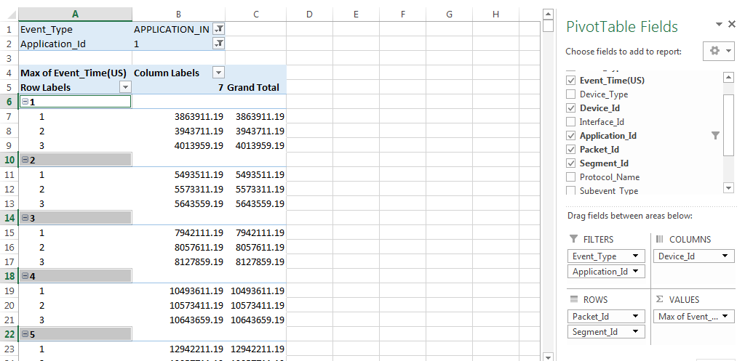

- Place the mouse just below Column Labels cell and left click then it will selects the rows of the pivot table as shown below
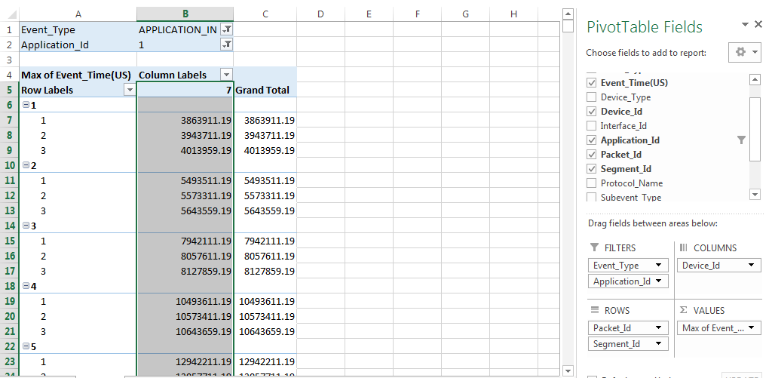
- Then in the Name Box name the column (APP_1 in this case), after that in an empty cell enter the formula to get the address of the empty rows Outside the pivot table
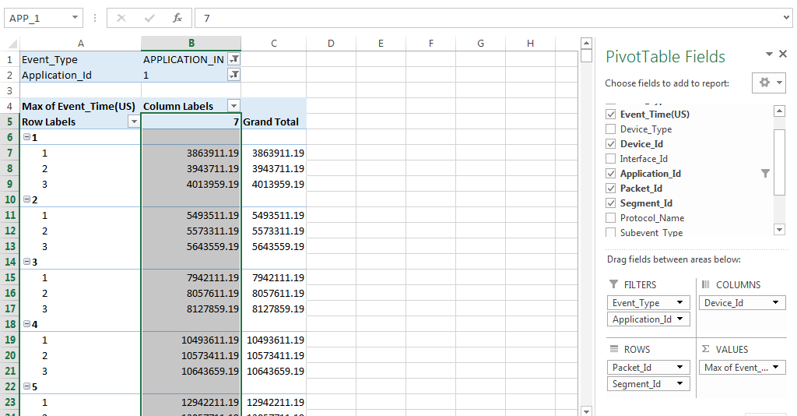

After that in an empty cell enter the formula =ADDRESS(ROW(APP_1)+1,COLUMN(D6))&":"&ADDRESS(ROW(APP_1)+ROWS(APP_1)-2,COLUMN(D6)) then press enter then you’ll get the address as shown below
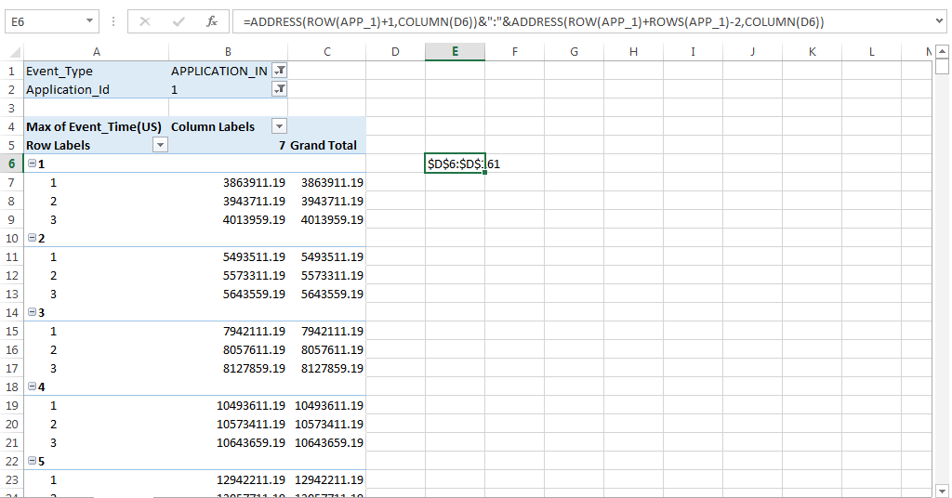

Then copy the address and place it in Name Box as shown below (Name Box is at the left top corner as shown below)
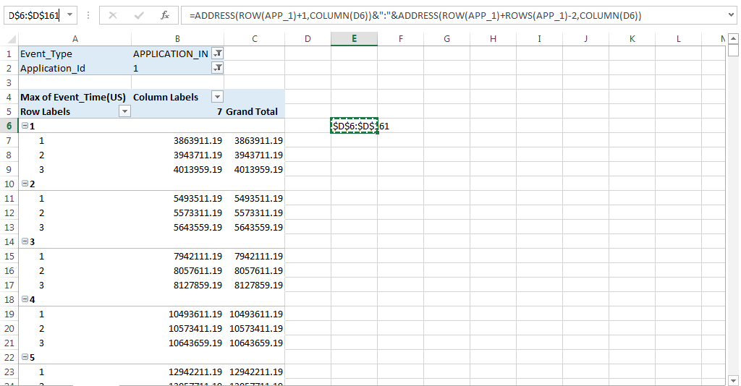

And press enter it will selects the Column D and Rows that are filled as shown
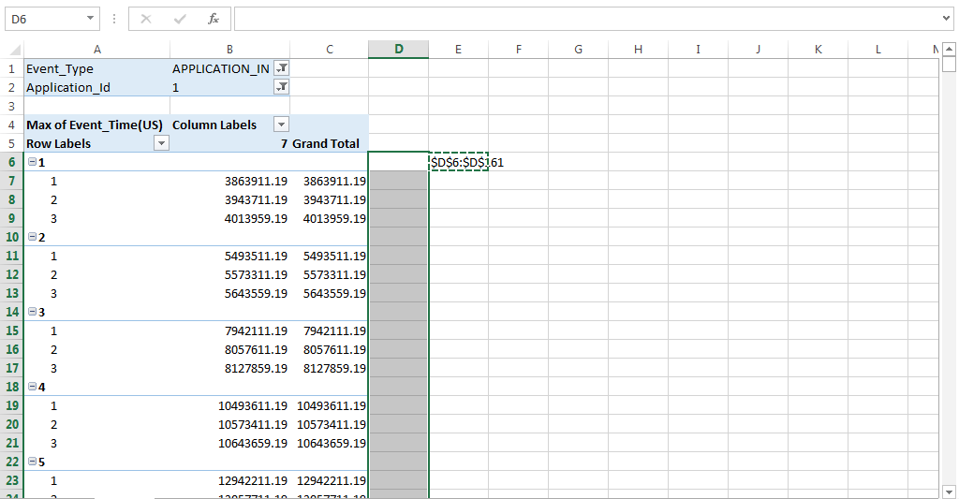

Then in the formula box type the formula =IF(B6<>0,IF(B5<>0,IF(B6<B5,1,0),IF(B6<B4,1,0)),0) and press CTRL + ENTER, it will fill the column with 0 and 1 , 1 if the current packet arrived before the previous packet that means it is an out of order packet , “0” when the packet arrived after the previous packet.

To get the Number of out of order packets enter the formula =SUM(D:D) (0 in this case)
